Business Proposal: CampusTrail — All‑in‑One Campus Travel Hub
Prepared for: E‑commerce (Term IV), IIM Kashipur
Prepared by: CampusTrail Project Team
Date: September 07, 2025
Version: v3.1 (Diagrams Edition)

Section 2 — Product/Service Information: Diagrams

2.3.0 Generic Rental Flow
Download SVG: /mnt/data/2.3.0_Generic_Rental_Flow.svg

2.3.1 Fest DSLR Rental
Download SVG: /mnt/data/2.3.1_Fest_DSLR_Rental.svg

2.3.2 Trekking Group Formation
Download SVG: /mnt/data/2.3.2_Trekking_Group_Formation.svg

2.3.3 Last-Minute Tripod
Download SVG: /mnt/data/2.3.3_Last_Minute_Tripod.svg

2.3.4 Club Gear Pool
Download SVG: /mnt/data/2.3.4_Club_Gear_Pool.svg

2.3.5 Damage Dispute Resolution
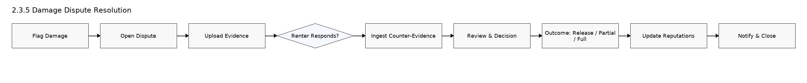
Download SVG: /mnt/data/2.3.5_Damage_Dispute_Resolution.svg

2.4.1 Deposit Hold/Capture/Release
Download SVG: /mnt/data/2.4.1_Deposit_Flow.svg

2.4.2 Dispute Resolution Flow
Download SVG: /mnt/data/2.4.2_Dispute_Resolution_Flow.svg

Appendix — Mermaid Source (for reference)
All diagrams are also provided as Mermaid code blocks in: /mnt/data/CampusTrail_Diagrams_Mermaid.md

